Lab Goal: To analyze a problem and involve branching and decision making in creating a solution for the problem. You must determine how times to hop, when to turn and most importantly when to stop. You must create commands based on the various requirements of this problem.

Lab Description: This lab requires you to use a wide variety of if commands. This type of programming involves not only using if but using else also. Failure to use the proper commands will mean your Jeroo is at risk as he may end up in the water or the nets.

Files Needed:

FinalDom.jsc

FinalDom.jev

Conditions: 3 Jeroos, 1 Jeroo per letter

Jeroos finish facing West.

Starting Screen:

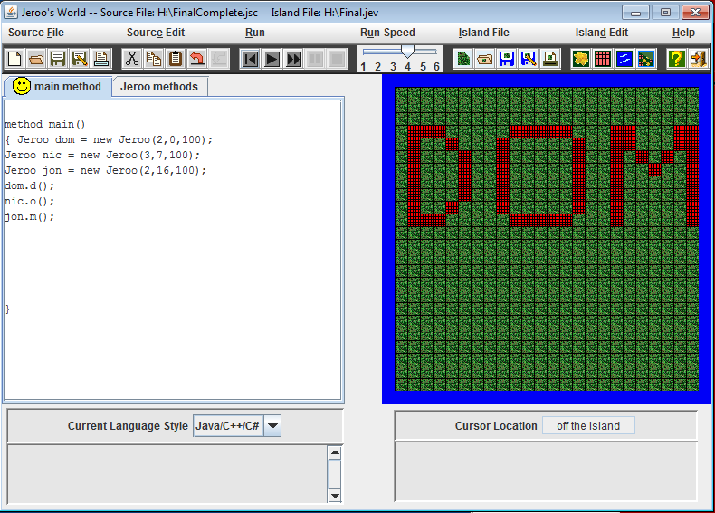

Ending Screen:

